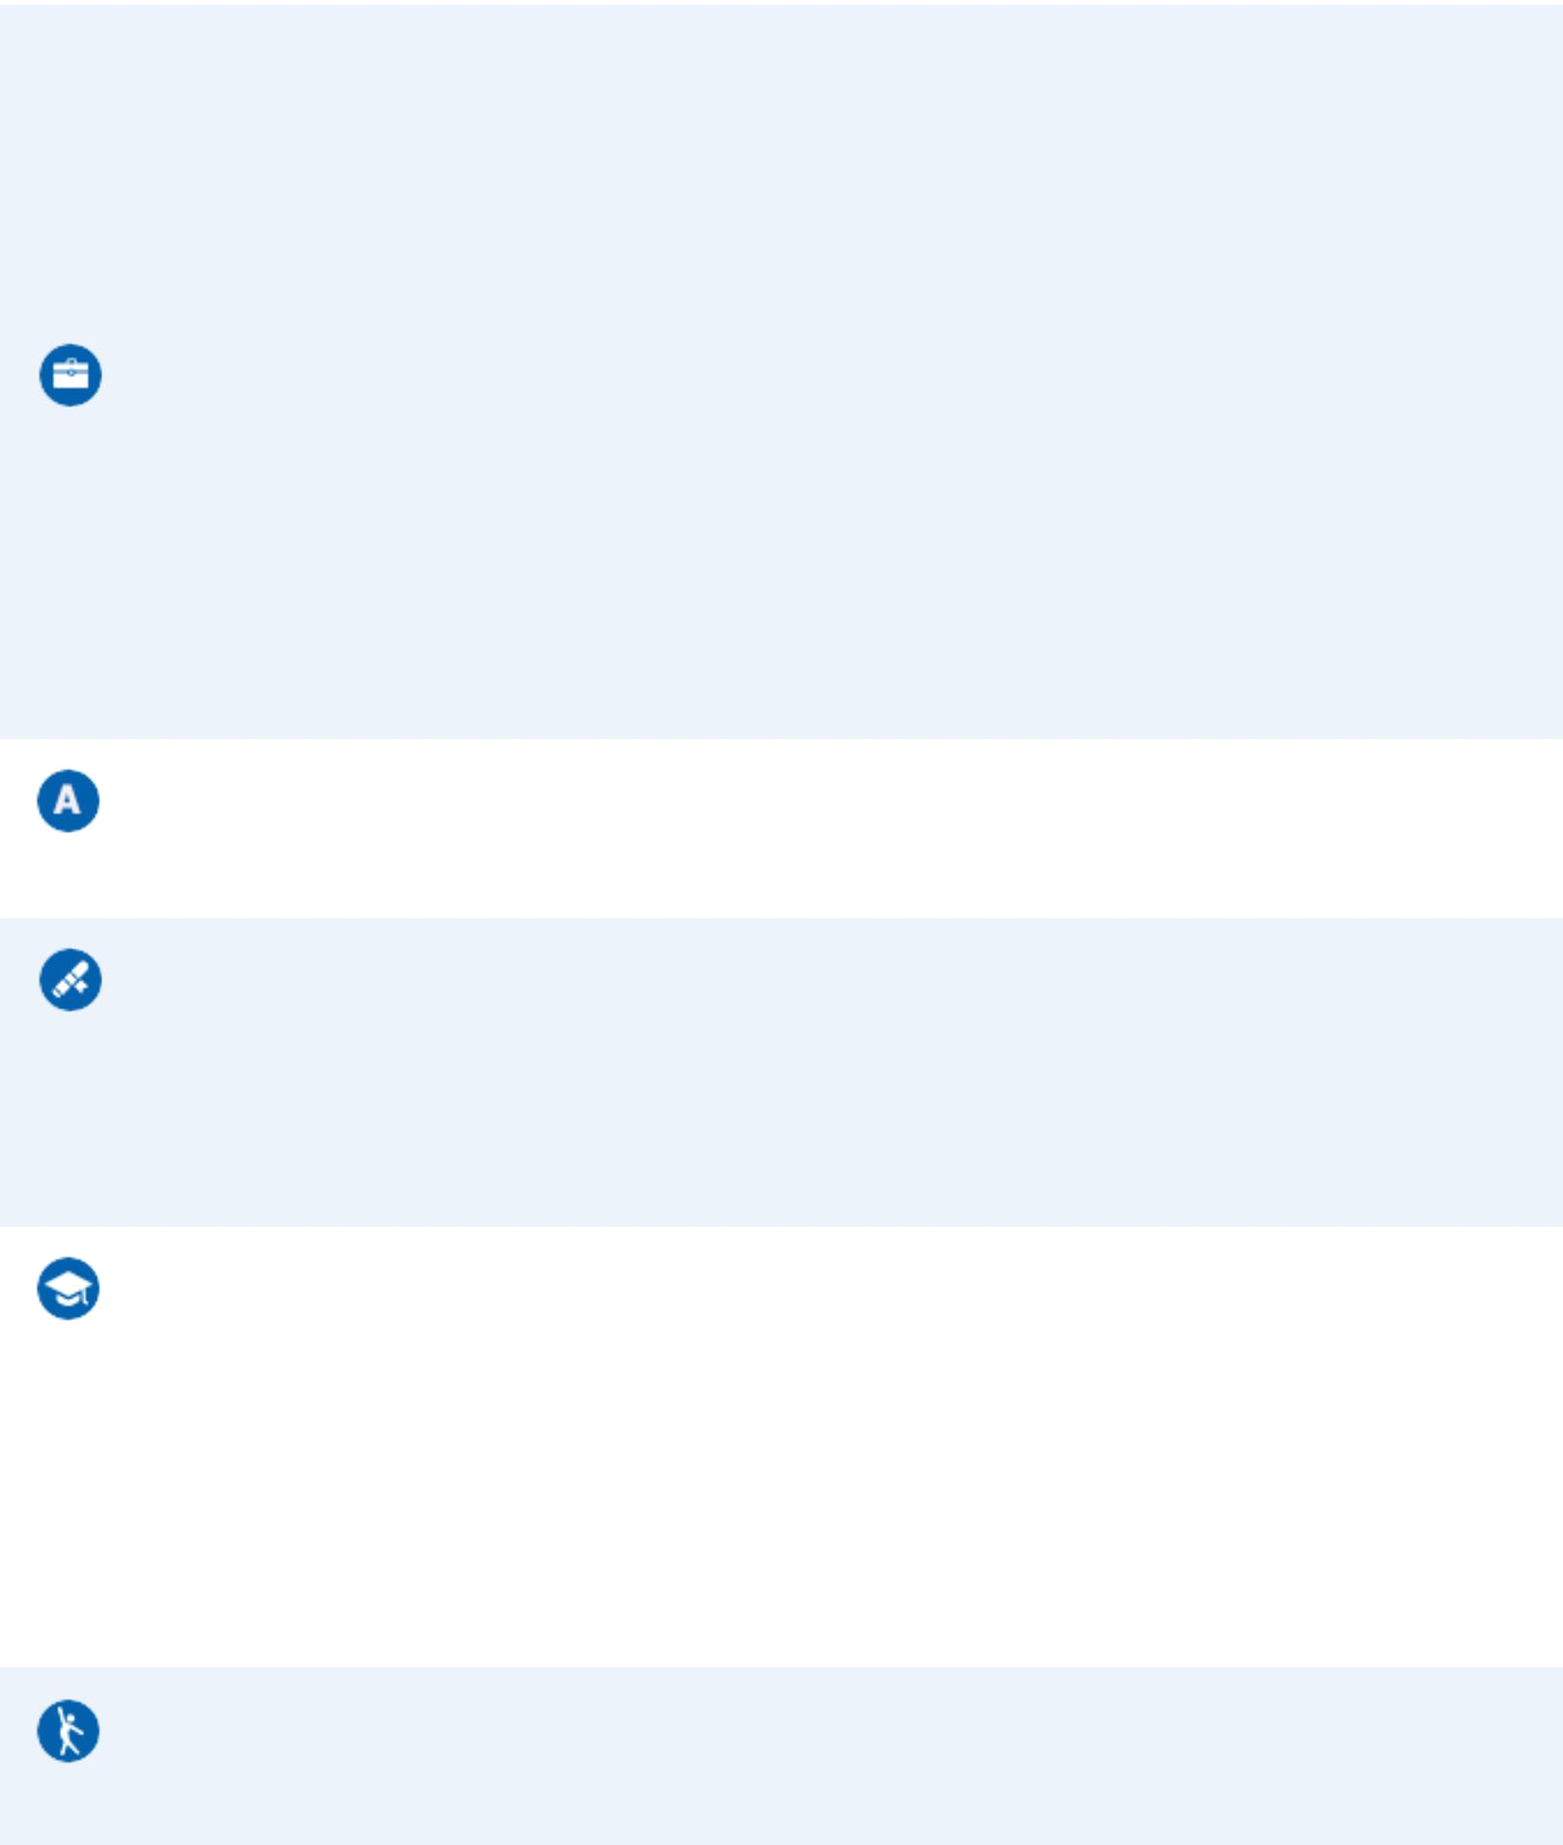
CURRICULUM VITAE | Email: Arunprakasam1994@gmail.com
Arun Kumar | Contact No.: 9543315088
gnanaprakasam

WORK EXPERIENCE

Lab assistant in a college

Sri Krishna polytechnic college

Arakkonam

From: 19/01/2015

Ref.email:

Arunprakasam1994@gmail.com

LANGUAGES KNOWN

Tamil, English

CERTIFICATIONS

SKILLS

Sslc

Computer

Diploma

EDUCATION

Diploma

79.79

Sri Krishna polytechnic college,

Arakkonam

From: 21/05/2011

To: 18/10/2014

HOBBIES

INTERESTS

Suffering internet, Watching TV, Reading books

Software side, Help to others

Powered by TCPDF (www.tcpdf.org)

